***How to buy an apartment in Ukraine?***

*5 january 2022*

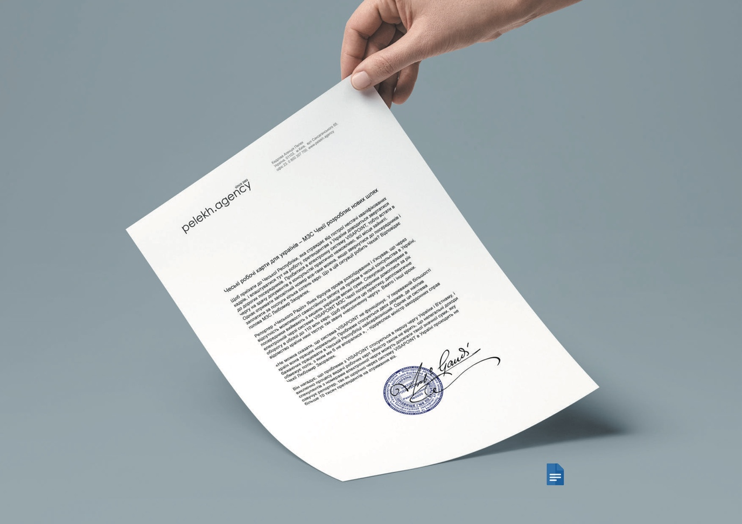

Foreign citizens have the right to buy and to own any kind of apartments in Ukraine. There are no restrictions on buying any kind of property in Ukraine, except agricultural land. Also, the number and size of apartments that a foreigner can own are unlimited. You can acquire an apartment in Ukraine for personal use, as an investment, or for rent. Foreigners in Ukraine do have the same rights in buying apartments as Ukrainian citizens. In this article, we will inform you about the particulars of the Ukrainian apartment acquisition process. Generally, there are two legal ways to buy a flat in Ukraine:

* Acquire already registered real estate from an owner (so-called secondary real estate);
* Buy an unfinished apartment from a developer company (so-called primary real estate);

Now you’re probably wondering, why buy an unfinished apartment when it is inconvenient to have to wait sometime before moving in? Well, Ukrainian tax law heavily favors the purchase of “primary” (unfinished) apartments. Basically, when you buy a primary property you pay a fixed tax of **0.5-2%**. When you buy a secondary (move-in ready) property, you must pay between **3.5%** and **8.5%** in tax and notary fees. So, there is a real tax incentive to buy an unfinished apartment in Ukraine.

In most of the developed world, investing in a construction project entails some waiting, but at the end of the process, you can expect to receive a finished apartment. However, in Ukraine, an apartment is considered finished once the bare walls have been put up and the building has been officially approved by the State Architecture and Building Inspectors of Ukraine. This means that after you have made the full payment for your property, you will still need to hire a contractor to finish the interior of your flat. If you do decide to purchase a primary property in Kyiv, we at Pelekh Estate will assist you with finding a reputable and reliable contractor for this end.

Very important thing is that all foreigners for property acquisition must have Ukrainian tax id number and certified translation of passport. Anyway, it is strongly recommended that the procedure of buying property in Ukraine is conducted by a qualified solicitor (legal adviser).

The Ukrainian housing market is growing very fast. In Kyiv, the capital of Ukraine, you will find really various buildings that are being constructed. Dozens of developers in Ukraine offer you a variety of apartments in Kiev. During this type of purchase, the buyer is named as an investor in Ukrainian apartment. You are not buying the apartment itself at the very beginning because from a legal point of view there is no official real estate meanwhile such property is being constructed.

In Kyiv alone, there are more than 15 000 apartments in more than 50 residential buildings that cannot pass the process of commissioning due to the problems with documents. Some houses have been constructed with no land ownership documents and investors can not get the property rights for apartments in such cases. Anyway, please consider that it is a bit riskier to purchase a flat at the stage of construction in Ukraine. But does not mean at all that you should avoid such an option. So if you have decided to buy a flat in a building under construction, you need to check property documents first. Legal due diligence of the construction company and of the needed permissions and available documents is strongly recommended. Consider also, that when you will come to the sales department of a Ukrainian developer or a construction company, the documents issued on the name of the house will be on the name of the company that is different from the name of the developer. It is normal in Ukraine.

Despite some of the potential issues we have highlighted, we would like to stress again that investing in property in Ukraine can be both a profitable and rewarding process. Good apartments can be found in the center for less than $100k and the typical rate of return for rental properties is from **5%** to **10%**… in cash! If talking about smaller cities like Uzhhorod you can buy good apartment for $50k and rent it for $500/month which gives you a 8-10 years return of investments.